Using the CCF Wellness Wheel©, rate each of the Six Components of Optimal Living, compared to your expectations for those areas (not comparing to “perfection,” other people, or to your past).

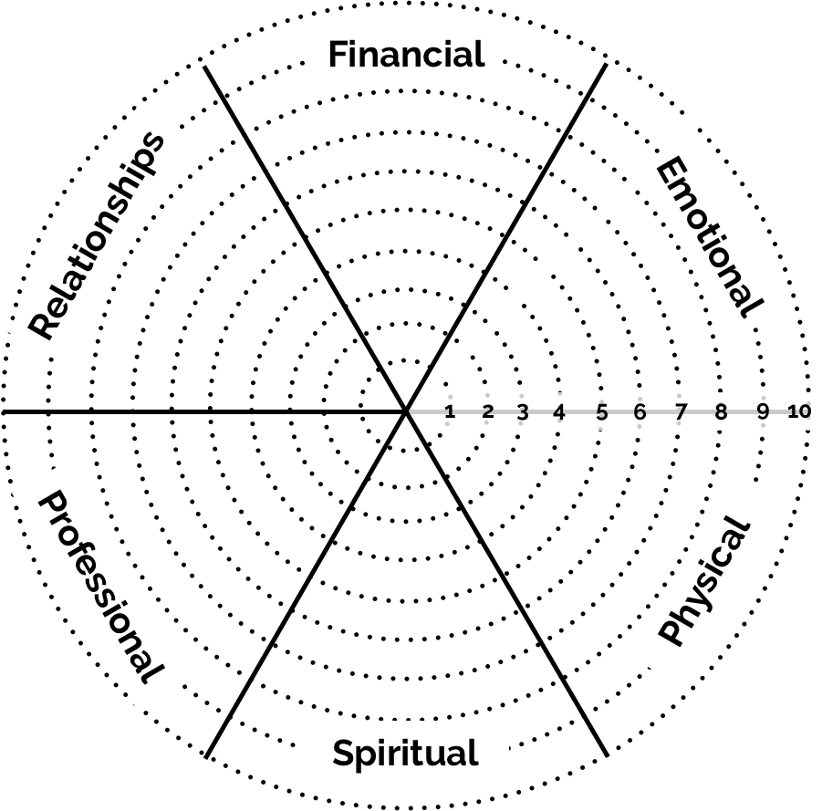

Rating: 1-4 is in need of improvement, 5-7 is satisfactory, 8-9 is great, and 10 is far exceeding expectations

Which two of the six key areas did you rate the lowest? (If there was a tie, choose the two that are most important to you)

1.

2.

Based on the areas of the CCF Wellness Wheel© that you rated the lowest, create some goals you would like to achieve in these areas:

